**Sunday Meetings**

**Morning Church** Sunday 9:30am (Hall)

Run with a children’s and teen’s program.

**Chinese Service** Sunday 9:30am (Lounge)

**中文崇拜**：每周星期日上午9:30 (小禮堂)

(粤华双语翻译)

第五星期日，中英文联合崇拜

**Night Church** Sunday 6:30pm (Hall)

A more contemporary service with supper held afterwards.

**Contact Us**

**Office** (02) 4961 3656

Pastor: Frank Cuthbertson 0404 934 660

Wilson Chan (华人牧者) 0422 325 888

Email info@islingtonbaptist.org.au

Web www.islingtonbaptist.org.au

chinese.islingtonbaptist.org.au

**ISLINGTON**

**BAPTIST**

**CHURCH**  180 Maitland Road,

Islington, NSW 2296

(Opposite Islington Park)

**中文堂**

**依斯灵顿浸信会**中文事工，致力服侍纽卡素地区华人，欢迎来自各地的华人，以我们的母语来敬拜。

　华语小组：每周星期日上午11:30

　粤语小组：每周星期五晚上 6:30

　长青团契：每月第二、四星期一上午10:30

　祈 祷 会：每周星期二晚上7:30

若有兴趣参与，请联络Amos (梁宜强弟兄)

电话：4952 8755 手机：0421 138 972

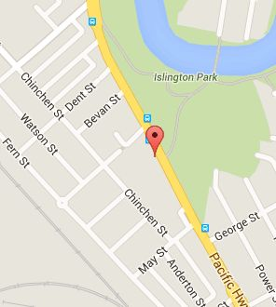

Church location

**Welcome to**

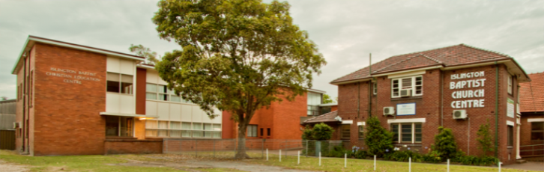

**ISLINGTON**

**BAPTIST**

**CHURCH**

Both English and Chinese Service in Newcastle

Our doors are wide open to people from all backgrounds. We have children, university students, youth and adults that come from many countries.

Our aim is to tell all people in Newcastle about the person and work of Jesus, while loving and helping those around us.

Together, we’re striving to become the kind of church described in the Bible with a focus on faithful Bible teaching.

IBC 2016 ©

**Play Time**

Playtime is for preschool aged children and their parents/carers. There is time for the children to play together, as well as planned activities, singing and morning tea. Regular social outings are planned throughout the year for both the parents and children. It’s a great way to connect with other young parents in the community.

**Thursday** 9:30am—11:30am

Church playground

**Sunday for Kids**

A special program is run for the children during the 9:30am Morning Church. We cater for individual children, running craft, games & Bible teaching which are accessible to each age group. If you have a family and are thinking of coming along to church, try the morning service and see what your kids think of it.

**Sunday** 9:30am—11:30am

Church

**Seniors**

Islington Baptist Church runs groups for seniors which organizes social events and trips regularly throughout the year. We value the importance of seniors’ ministry within the community.

If you would like information about this group, please call Pastor Frank.

We also hold services at the MAROBA Aged Care facility which our church founded.

**Sunday** 9:30am—11:30am

MAROBA

**IBY**

This group is for teenagers in high school. Come along to enjoy a BBQ dinner, hang out with friends, play games, talk about issues, hear what the Bible is about and go on the occasional outing. Our leaders will look after all who come along.

**Friday** 6:30pm—8:00pm (school term)

Church hall

**Connect Groups**

Connect Groups are a great way to connect people to the church and also to connect the Bible to the meaning for today.

**Sun.** 11:30 am **Mandarin Bible Study** (Lounge)

**Jeffrey** 0432-078-256

5:45 pm **Prayer Meeting** (Lounge)**Bob** 4968-4061

**Mon.** 6:30 pm **Young Adults’ Bible Study** (Maryland)

**Khalil** 0408-240-467

**Tues.** 10:15 am **Ladies Group** (Lounge)

**Caron** 0412-952-911

7:30 pm **Prayer Meeting** (Chinese Church)

**Wed.** 6:30 pm **Bible Study** (Lounge) **David** 4963-1644

7:00 pm **Bible Study** (Adamstown Heights)

**Frank** 4957-5316

**Thur.** 9:45 am **Playtime** (Lounge) **Lisa** 0404-844-086

**Fri.** 7:00 am **Prayer** (Lounge)**Angelo** 0412-447-577

9:30 am **Mothers’ Group** (Fletcher)

**Lisa** 0404-844-086

10:00 am **KYB** (Lounge) **Sharon** 4969-7577

1:30 pm **Maintenance** (Church) **Ian** 4957-2974

6:30 pm **Youth Group** (Hall)

**Joshua** 0431-217-591 or

**Lizelle** 0432-881-153

6:30 pm **Cantonese Bible Study** (Rankin Park)

**Amos** 4952-8755

7:30pm **TIBBS** (Rankin Park) **Khalil** 0408-240-467